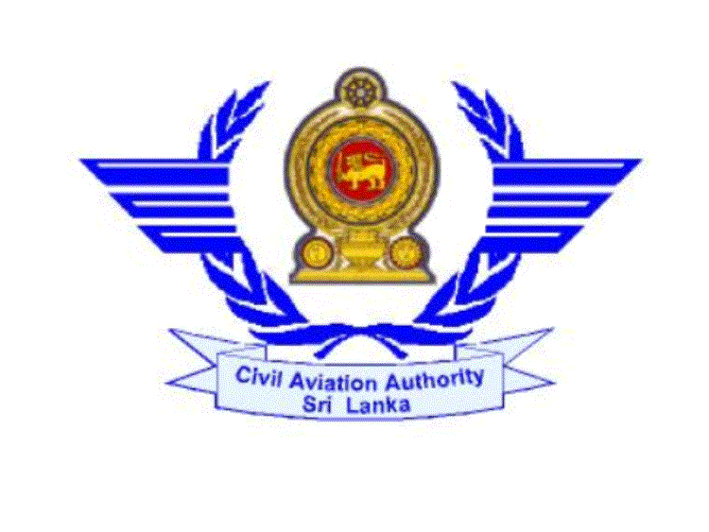
CIVIL AVIATION AUTHORITY OF SRI LANKA

APPLICATION FOR CONVERSION OF FOREIGN LICENCES TECHNICAL EXAMINATION

PPL CPL

CPL\IR ATPL
√

1. (a) Full Name :…SUDATH RANIL WICKRAMASINGHE ………..………………..…….
…………………………………………………………………….………..
(Please complete this in BLOCK LETTERS)
(b) Name with initials: .…S. R. Wickramasinghe ………………………….…………….……..
2. Permanent Address: …04, Galle Road, Colombo – 04 ……………………………….…….…….
………………………………………………………...………………………………….……..
3. Telephone No.: …0777300550 ………….…… 4. Fax No…..…0112356784 ………….………

5. Email Address: …rwickramasinghe@yahoo.com ……….. ……………………….……………

6. Nationality: ……Sri Lankan……………….…… 7. Date of Birth: D..03..M…04…Y…1995..

8. ID/Passport No : …9500045123V………….

9. PPL/ CPL/ CPL-IR/ ATPL License No. (If any)…CPL/IR-3348531……….

10. Subjects applied for
*Please apply the time in between 0900-1600 hrs on working days.

No | Subjects | Date | Time | Remarks
1 | Air Law & Operational Procedures | 10/11/2011 | 10.00am
2 | Composite Paper- 01
3 | Composite Paper- 02
4 | Composite Paper- 03

11. (a) Is this your first attempt Yes No (b) If “No”, the dates of First attempt: ……………..
√

12. Subjects passed in previous attempts:

No | Subjects | Attempt No | Date
1
2
3

I certify that the above particulars furnished by me are true and accurate to the best of my knowledge.

…05/11/2011…… ...........Ranil............
Date Signature of the candidate

