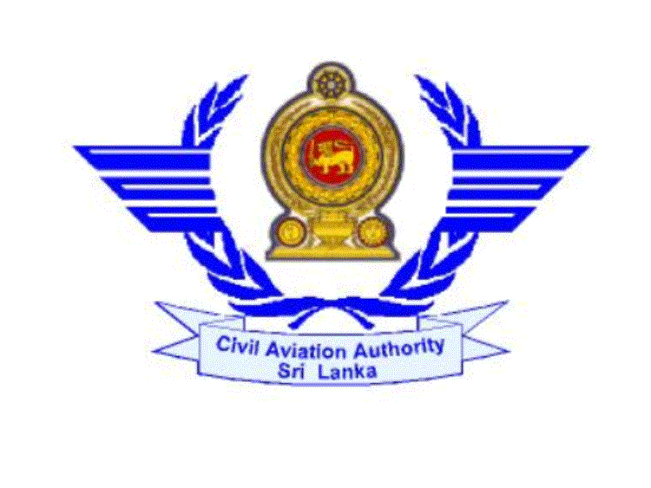

CIVIL AVIATION AUTHORITY OF SRI LANKA

APPLICATION FOR A COMMERCIAL PILOT LICENCE

(AEROPLANES/HELICOPTERS)

I hereby apply for a Commercial Pilot Licence and certify that the particulars given by me in this form are true and correct to the best of knowledge and belief.

1.Name(A)Surname:…Abeysekara………………………………… (B)OtherNames:…RanganaPrasad………………….………………

2. PermanentAddress: No.23,Galleroad, panadura……………………
………………………………………………………...……………..

3. Telephone No.: 0112445214……… 4. Fax No…..……………………

5. Email Address: …abbey@gmail.com…………………………………………………

6. Nationality: Sri lankan………………………………………………

7. If not a Sri Lankan, purpose of conversion …………………

8. Date of Birth: D…..05…M 06…Y 1987…… Place of Birth… panadura …

9. (A) State whether you have passed the approved course of training for CPL :
Yes………………………………………………………………………..

(B) Name and Address of the flying schools at which you have undergone training
…APE Aviation INC, 600, Skyline Drive, FAA, USA…………..
…………………………………………………………………………………..

10. If you are not a citizen of Sri Lanka state whether you have followed the course for CPL
in Sri Lanka or seek employment in Sri Lanka : …………………………………………
Name of the Flying school/ Airline should be mentioned:
…………………………………………………………………………………………….
…………………N/A…………………………………………………………………….

11. Particulars of licence already issued to you by this Authority:
SPL No. : SPL/A/895……………………………………………………………………
PPL No. : PPL/A/658…………………………………………………………………

12. If you apply for conversion of a foreign CPL, give the following particulars:
i. Number: ………5327458…………………………………………
ii. Date of Issue: …15.06.2010……………………………………………
iii.Last date of validity: …………………………………………………………….
iv.Issuing Authority and Country: …………………………………………………

13. Medical Examination:
i. Date of last medical examination: ………12.08.2011……………………
ii. Class of medical examination : ………Class i………………………….
iii. Last date of validity of medical examination: ……11.08.2012………….

14. Flying Experience:
  - i. Total No. of hours as PIC : ……………168.9………………………………..
ii. Total No. of hours as PIC under supervision : ……18.3……………….............
iii. Solo : …………129.5……………………………………………………………
iv. Dual : …………57.7………………………………………………………………
v. Co-Pilot : ………-………………………………………………………..
vi. Total No. of hours : …266.8………………………………………………….

B. Cross Country Hours:
- Number of hours as PIC:…127.4……………………………………………..
- Date of X Country Flight – not less than 300 n.m. (540 k.m.) with full stop landings at two different points: …03.06.2011……………………

C. Night flying:
- No. of hours as PIC: …113.3…………………………………..
- No. of hours under supervision: …9.1………………………
- Total No. of hours: ……122.4…………………………………
- No. of unassisted take-offs/ landings: 7.6……………………...

D. Recent Flying:
i. No. of hours as PIC during the 6 months immediately preceding the date of
this application : ……106.6……………………………………………

- (Please attach a summary sheet of ‘X’ Country & Night PIC hours)
15. Instrument Flying:
- No. of dual instrument flight instructional hours received: 50.6…
- No. of instrument flying hours on aircraft: …50.6……………….
- No. of simulated instrument flying hours: ……33.3………….
- Total no. of instrument hours: ………83.9………………….

16. Types of aircraft, which you request to be included in the licence.

 | Types of aircraft | Date of most recent flight | Whether in Group 1 or 11
01 | PA-44 | 04.22.2011
02 | C 172 | 02.15.2011
03 | C 150 | 05.08.2009
04
05
06

I received Pamphlet No. PL/P/03 or PL/P/04.

………………………… ………………………………..
Date Signature of Applicant

………………………………….. …………………………
Delivery Date Delivery Time

