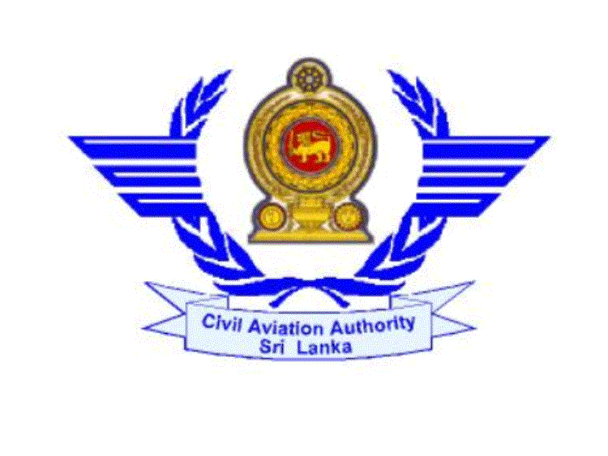
CIVIL AVIATION AUTHORITY OF SRI LANKA

ENGLISH LANGUAGE PROFICIENCY CHECK EVALUATION FORM

Particulars of the applicant

1. Full Name (In Block Capitals) : SUDATH RANIL WICKRAMASINGHE …………..……….….
………………………………………………………….……...
2. Contact Number : 0777300550….. E mail : …rwickramasinghe@yahoo.com……
3. Nationality : Sri Lankan … Licence Issuance Authority: CAASL……………

4. ID No. / Pass Port No. : …950045123V…….

5. Licence Number/ Type of Licence applied for : …ATC 101 ….

6. Name of the Airline/Organization: …Airport & Aviation (SL) Lted …………………………………

7 ELPC Required Date *: (* ELPC is usually conducted only once a week on Thursdays at 2.00 p.m.)
15/11/2011

8. Applied for : Licence Issuance Licence Conversion Ratings Renewal
√
04
9. If ELPC is already done: Previous Level Expiry Date

Signature : …Ranil… Date : …05/11/2011…..

Official Use Only
Evaluation Criteria | 1 | 2 | 3 | 4 | 5 | 6
PRONUNCIATION
STRUCTURE
VOCABULARY
FLUENCY
COMPREHENSION
INTERACTION

Very Proficient Non Native / Native Speaker Yes No

ICAO Language Proficiency Level
(Lowest rating among individual ratings)
Remarks

INTERVIEW PANEL
Name Designator Signature Date
1. ………………………………………………………………………………………………….…….….
2. ……………………………………………………………………………………………………..…….
3. ……….………………………………………………………………………………………….……….

