CONFIDENTIAL Form No: /CAA/PL/I/11

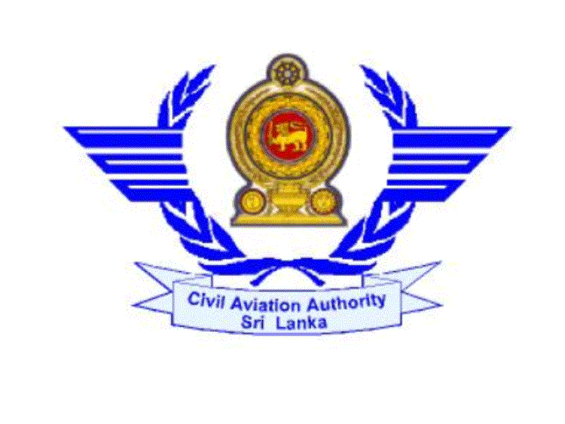

CIVIL AVIATION AUTHORITY OF SRI LANKA

APPLICATION FORM FOR FLIGHT INSTRUCTOR’S RATING (AEROPLANE)

- Full Name: - Mr. /Ms. XXXXXXXXXXXXXX …………………………………………….
………………………………………………………………………………………………..
- Date of Birth : 01.01.2011 ……………...................................................................................
- Permanent Address :- No. 001, main street, Colombo 01. ..……………………………… ……………………………………………………………………………………………….
- Telephone/Fax No/E-mail No: 011 2333998, E- Mail xyz @ aaa.gmail.com ………..…….
- Whether you have followed an approved Course of Training: Yes ……………………….…
- Name and Address of the Organization: SriLankan Airlines .………....................................
- Instructor Rating Certificate No: IC/SW FAA/0023546789 .….…………………………….
  - Date of Issue:- 05.11.2011 ……………….…………………………………….…….
  - Date of Expiry:- 04.11.2017 ……………..…………………………………………..
  - Issued Authority:- FAA - USA…………….……………………………………..…..
- Licence held: CPL/ATPL No; CPL ...……………….……………………………………….
  - Date of Issue: - 11.03.2010 …………….…………………………………………….
  - Issuing Authority:- FAA –USA …………..………………………………………….
  - Date of Expiry:- Perpetual ………………………..………………………………….
  - Last date of Medical Exam:- 02.09.2010 ………………..…………………………..
  - Date of Expiry: - 01.09.2011 …………..……………………………………………
(Please attach a copy of the Licence & Medical Certificate if the Licence was issued by a Foreign CAA)

- Category of aircraft :- Aeroplane
  - Class Rating :- Single Engine Land / Multi Engine Land
  - Type Rating:- C 152 ……………………….…………………………………………
(A/C Types)

A/C Types | Single Engine Land |  |  |  | Multi Engine Land |  |  |  | Total | No of Instructional  hours on each type
A/C Types | PIC |  | Dual / Co-Pilot |  | Dual |  | Co-Pilot |  | Total | No of Instructional  hours on each type
A/C Types | Day | Night | Day | Night | Day | Night | Day | Night | Total | No of Instructional  hours on each type
C 152 | 520.55 | 27.15 | 125.15 | 12.5 | 10.5 | 2.5 | 171.5 | 23.25 | 531 | 453.25
C172 | 54.5 | 54.5 | 62.25 | 98.05 | no | no | no | no | 54.05 | 52.25
Total | 571.05 | 81.65 | 187.40 | 110.55 | 10.5 | 2.5 | 171.5 | 23.25 | 585.05 | 505.5

- Do you hold AFI rating issued by this authority: - No …………………..………………….
- When did you last Instruct: - Australia …………………………............................................
Give types of aircraft and dates, and number of
Instructional hours during last twelve months: - C 152 54.5 hrs ……..…………………......
No of Instructional hours during training:- 27.05 hrs …….………………………………..
No of Instructional hours after the rating:- 27.45 hrs ………………………………………..
I hereby certify that all the particulars given by me above are true & correct
…… 18th June 2011 …… ………………………………..
Date Signature of Applicant

Note :- Please attach the copies of all relevant documents.

