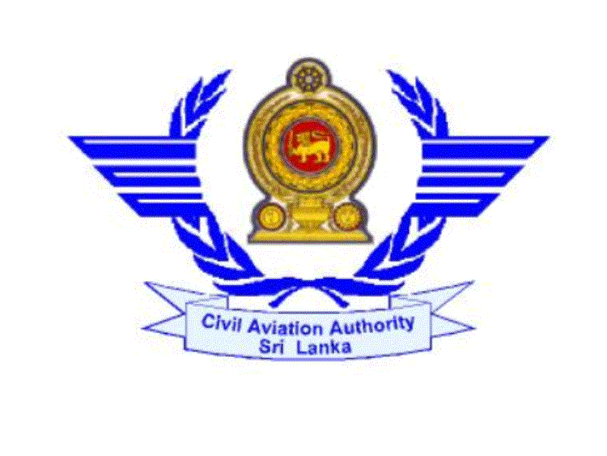

CIVIL AVIATION AUTHORITY OF SRI LANKA

APPLICATION FOR PRIVATE PILOT’S LICENCE (AEROPLANE)

I holder of Student Pilot Licence No. SPL/A/563 valid until …12.03.2012… request for issuance of a Private Pilot Licence, and certify that the particulars given by me in this form are true and correct to the best of my knowledge and belief.

( 1 ).Personal Particulars:-

1. Name (A) Surname: …Tennakoon……………………………………….
(B) Other Names: …Pubudu………………………….…………….

2. Permanent Address: …No:65, Negombo road, Seeduwa………...……………………..
………………………………………………………...……………..

3. Telephone No.: 0112586359……… 4. Fax No…..……………………………

5. Email Address: …pub@ymail.com……………………………………………….………

6. Nationality: …Sri lankan…………………………….…………………….

7. Date of Birth: D…25…M…12……Y…1990……… Place of Birth…Negombo……..

( 2 ).Medical Fitness:-

I. Date of the last medical Exam with CAASL:……21.02.2011………… II. Class:- …I…….………
III. Did you suffer from any defect disability or from any disease since the date of the last medical exam:- Yes/No
IV .If yes please give details:-………………………………………………………………………….. ………………………………………………………………………………………………………
( 3 ).Training:-
I. Did you complete an approved training course :-Yes…………………………………………
II. Name of the training organization :-…Cosmos Aviation Pvt Ltd.…………………
III. Course duration ……10 Months……………………………………………
IV. Name of the instructors:-
(a)Ground……I Wijesekara………………….
(b)Flying ……Capt , Rithik Khan…………..

V. No .of hours of dual instruction received:-
(a) Day……33.5………………………………………………
b) Night …03.0…………………………………………
( Please attach the course completion certificate )

( 4 ).Technical examination results( Theory /RT Practical):-
Subject Date of Exam Results
I …Airlow 12.04.2011 pass
II…Aircraft General 12.04.2011 pass
III Flight performance 12.04.2011 pass
IV Human performance 13.04.2011 pass
V…Meteorology 13.04.2011 pass
VI…Navigation 13.04.2011 pass
VII ELPC…… 18.04.2011 pass
VIII RT……… 18.04.2011 pass

( 5 ).Flying Experience:-
- Type of Aircraft flown :-…Cessna 152……………
II. Total flying time :-…53.50………………………
(a) Total No. of hrs…53.50…………………….
(b) Solo:-…17.55……………………………
( c) Dual:- 35.55…………………………..
(d) Dual cross country:-…03.45………………
(e) Solo cross country:-…07.05……………….

III. Long cross country flight:-……………………………
- Date…28.09.2011…..
- Route,:-…vccc, vccw, vcck…
- Aerodromes landed ( full stop landings) ……03….
IV. Night flying:-…………………………………
( a) No .of hrs:-……05.35………………………
( b )No of take off , landing: and navigation by night:-…t off -31/ landing 31…….
V .Instrument time:-…05.15………………

( 6 ).Rating applied for:-
I. Class:-
(a ) Single engine land
(b) Single engine sea
(c) Multi engine land
(d) Multi engine sea

II. Aircraft types
( a )…Cessna 152………….
( b )…………………………………..

( 7 )Attachments :-
( a ) Course completion certificate
( b ) Log book and a copy of the last certified page of log book
( c ) Photograph ( 2CmX2.5Cm ) two copies
( d ) Any other………………………………………

( 8 ) Applicable Fee :-

I received Pamphlet No. PL/P/02.

………………………… ………………………………..
Date Signature of Applicant

………………………………….. …………………………

Delivery Date Delivery Time

