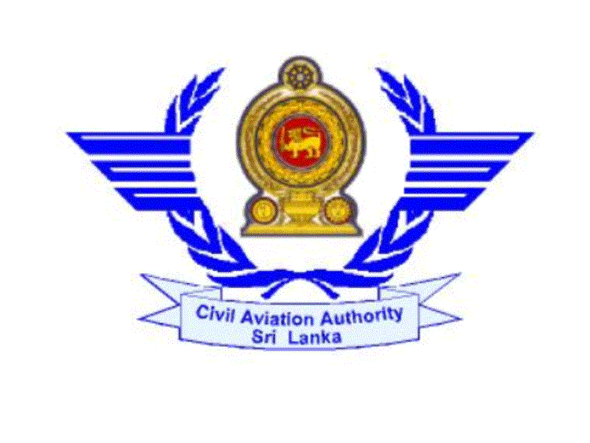

CIVIL AVIATION AUTHORITY OF SRI LANKA

APPLICATION FOR A COMMERCIAL PILOT LICENCE

(AEROPLANES/HELICOPTERS)

I hereby apply for a Commercial Pilot Licence and certify that the particulars given by me in this form are true and correct to the best of knowledge and belief.

1. Name (A) Surname: ……weerasinghe…………………….
(B) Other Names: …Tharidu sampath….……………………………….

2. Permanent Address: ……45/A, kandy road, kadawatha………………………………
………………………………………………………...……………..

3. Telephone No.: …01125364879………… 4. Fax No…..……………………………

5. Email Address ….weera@yahoo.com ……………………………….………

6. Nationality: ……Srilankan……………………………….…………………….

7. If not a Sri Lankan, purpose of conversion ………………………………………………..

8. Date of Birth: D…23..M 03…Y…1987……… Place of Birth……Ragama……

9. (A) State whether you have passed the approved course of training for CPL :
…………………………………………………………………………………..

(B) Name and Address of the flying schools at which you have undergone training
…Sriya Aviation training Academy, Colombo Airport Ratmalana…..
…………………………………………………………………………………..

10. If you are not a citizen of Sri Lanka state whether you have followed the course for CPL
in Sri Lanka or seek employment in Sri Lanka : …………………………………………
Name of the Flying school/ Airline should be mentioned:
…………………………………………………………………………………………….
…………………………………………………………………………………………….

11. Particulars of licence already issued to you by this Authority:
SPL No. : …SPL/A/1919……………………………………………………………
PPL No. : …PPL/A/1235……………………………………………………………

12. If you apply for conversion of a foreign CPL, give the following particulars:
i. Number: …………………………………………………………………………
ii. Date of Issue: ……………………………………………………………………
iii.Last date of validity: …………………………………………………………….
iv.Issuing Authority and Country: …………………………………………………

13. Medical Examination:
i. Date of last medical examination: …10.10.2011……………………………
ii. Class of medical examination : …CAASL I…………………………………….
iii. Last date of validity of medical examination: …09.10.2012……………….

14. Flying Experience:
  - i. Total No. of hours as PIC : ……73.2…………………………………………..
ii. Total No. of hours as PIC under supervision : ………49.5………….............
iii. Solo : ……122.6………………………………………………………………
iv. Dual : ……60.0………………………………………………………………
v. Co-Pilot : …-……………………………………………………………..
vi. Total No. of hours : ……182………………………………………………….

B. Cross Country Hours:
- Number of hours as PIC: ……51.6……………………………………………..
- Date of X Country Flight – not less than 300 n.m. (540 k.m.) with full stop landings at two different points: …23.06.2011………………

C. Night flying:
- No. of hours as PIC: ……7.2……………………………..
- No. of hours under supervision: ……6.6………………………
- Total No. of hours: ………15.8……………………………………
- No. of unassisted take-offs/ landings: ……29…………………...

D. Recent Flying:
i. No. of hours as PIC during the 6 months immediately preceding the date of
this application : ………9.5…………………………………………

- (Please attach a summary sheet of ‘X’ Country & Night PIC hours)
15. Instrument Flying:
- No. of dual instrument flight instructional hours received: …10.6…
- No. of instrument flying hours on aircraft: …43.5….
- No. of simulated instrument flying hours: …-…….
- Total no. of instrument hours: ……43.5……………….

16. Types of aircraft, which you request to be included in the licence.

 | Types of aircraft | Date of most recent flight | Whether in Group 1 or 11
01 | Cessna 152 | 30.10.2011
02 | P A 32 | 04.05.2011
03
04
05
06

I received Pamphlet No. PL/P/03 or PL/P/04.

………………………… ………………………………..
Date Signature of Applicant

………………………………….. …………………………
Delivery Date Delivery Time

