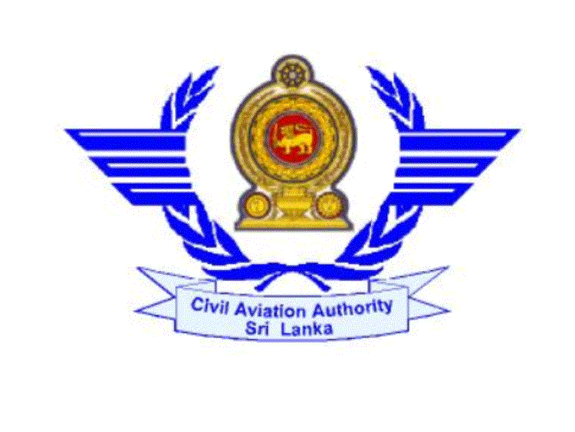

CIVIL AVIATION AUTHORITY OF SRI LANKA

APPLICATION FOR PRIVATE PILOT LICENCE TECHNICAL EXAMINATION

1. (a) Full Name :…SUDATH RANIL WICKRAMASINGHE.………………………
(Please complete this in BLOCK LETTERS)
(b) Name with initials:. …S. R. Wickramasinghe..………………………...………………..
2. Permanent Address 04. Galle Road, Colombo - 04………………...………………..…. ………………………………………………………...………..…..
3. Telephone No.: …0777300550……………… 4. Fax No…..011 2356784 ……….………….

5. Email Address: …rwickramasighe@yahoo.com.………………………………….……………

6. Nationality: Srilankan………………… 7. Date of Birth: D…03.…M……04…Y…1995……

8. ID/Passport No :…950045123V……………………………………….

9. (a) Name of the Flying school: …Skyline Aviation………………………………………..……
(b) Address :…3. Airport Road, Ratmalana……………..………………………….……
……………………………………………………………………………….
10. Student Pilot Licence No :……SPL/A/2065……Last date of validity: ……05/02/2012 …..….

11. Subjects applied for :
*Please apply the time in between 0900-1600 hrs. on working days.

No | Subjects | Date | Time | Remarks
1 | Air law, ATC Procedures & Operational Procedures  (01 hour & 15 minutes) | 11/11/2011 | 09.00am
2 | Aircraft General Knowledge & Principles of Flight  (01 hour & 15 minutes) | 11/11/2011 | 10.30am
3 | Flight Performance and Planning (01 hour) | 11/11/2011 | 11.00am
4 | Human Performance and Limitations (30 minutes) | 11/11/2011 | 12.30am
5 | Meteorology (30 minutes) | 11/11/2011 | 01.30pm
6 | Navigation & Communication Theory  (01 hour & 30 minutes) | 11/11/2011 | 2.15pm
7 | English Language Proficiency Check
8 | Radio Telephony
√
- (a) Is this your first attempt Yes No

(b) If “No”, the dates of First attempt: ………………………………………………………………….

13. Subjects passed in first and other attempts:

No | Subjects | Attempt No | Year & Month
1
2
3
4
5

14. Flying Experience :
Dual Solo
- Hours claimed as Pilot of Aeroplanes …15….. …05….

(b) Night Flying …..1.… ….00….

(C) Cross Country ….3….. …..1…..

(d) Instrument Time …0.5….. …00….

15. Type of Aircraft : Cessna …152...

I certify that the above particulars furnished by me are true and accurate to the best of my knowledge.

Date : …05/11/2011…… ……………Ranil………………..

Signature of the candidate

Certificate by the Chief Instructor of the Flying School

Director General of Civil Aviation,

I certify that the above named candidate
(a) is a student enrolled at ………………………………………………………….Flying Training School
approved by the Director General of Civil Aviation and,

(b) is following the Private Pilot Licence Course approved by the Director General of Civil Aviation and,

(c) has completed ………………….hours of flying training

(d) has completed ground school syllabus for Private Pilot Licence Technical Examination.

Signature : ……………………………….

Name : …………………………………………………………………….

Designation : ………………………………………………………………………
(Place official stamp)

Date : ………………………….

