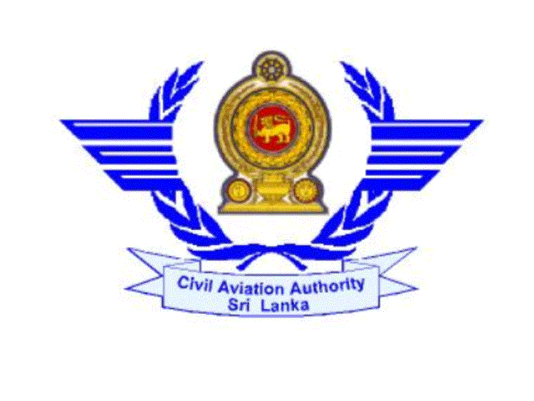
Payments Made
Express Evaluation
Normal Evaluation

CIVIL AVIATION AUTHORITY OF SRI LANKA

APPLICATION FOR RENEWAL OF PRIVATE PILOT’S LICENCE
( Please read instructions overleaf before completing this application )

I hereby apply for the renewal of my Private Pilot Licence No. PPL/A/952……………..

( 1 ).Personal Particulars:-

I. Name (a) Surname: …Ruwanpathirnage……………………………………..
(b) Other Names: …Chaminda………….……………………..

- Permanent Address: ………3/95, Galle road, Dehiwala.………………………… ……………………………………………………………………………………………………….
- Telephone No.: …0112532689……… Fax No…..……………………………………...

IV. Email Address: ………cham1@ymail.com…..………………………………….………

V. Nationality: ……Sri lankan…………………………….……………………………..

VI. Age:-…20 Date of Birth: D 15…M 05…Y 1991 Place of Birth:…kalubowila ….

( 2 ). Flying Experience:-

I. Aircraft type/types on PPL and the last date of flying on these types:-.............................................
II. Have you flown any additional types:-..............................................................................................
III. If yes, give details and proof:-..........................................................................................................
Class Types | Hours claimed as Pilot - In - Command |  | OFFICIAL USE ONLY
Class Types | Preceding 12 months | Grand Total | OFFICIAL USE ONLY
Land Planes  Seaplanes  Helicopter | ...…8.5hrs…….  ..…………………….  ………………………. | ………10.5hrs………..  ...…………………….  ………………………..

IV. Are you continuing your flying training in SriLanka or abroad? If so give the flying school name, address and contact numbers:-................Abroad...............................................................
..........................................................................................................................................................
..........................................................................................................................................................

( 3 ).Medical Fitness:-

I. Date of the last medical Exam with CAASL:……13.11.2011……… II. Class:- ………I……….
III. Did you suffer from any defect disability or from any disease since the date of the last medical exam:- Yes/No
IV .If yes please give details:-…………………………………………………………………………… …………………………………………………………….………………………………………………………………………………………………………….………………………………………

Date: …………..………….…… Signature of Applicant: …………..…….……….

Instructions

This form, when completed, should be forwarded to the Personnel Licesing Section, Civil Aviation Authority of SriLanka ,No: 02, Hunupitiya road, Colombo 02.
- Your Private Pilot Licence,
- Your personnel flying log book, entered and totaled to date & certified.
(iii) The applicable Fee for licence renewal & Medical Exam
( iv ) A PPL holder who follows CPL training on the strength of SriLankan PPL abroad should submit the following documents,
( a ) Letter from the flying school certifying his / her training and the number of hours
flown abroad.
( b ) Medical test and detailed Medical report from the DME of the country.

………………….. …………………..
Delivery Date Delivery Time

